NauDia1000

PAT: Ontwerpsdokument

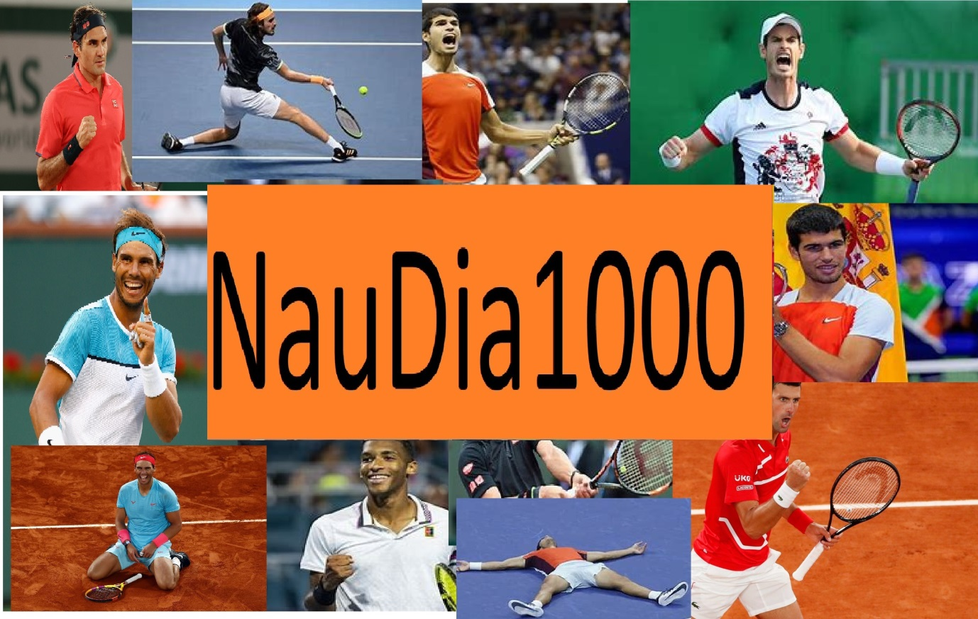

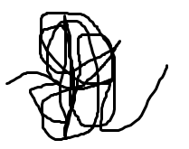**-Logo**

**DIAN NAUDE 18 October 2021**

**Table of contents**

1 TASK 1 4

1.1 A: TAAKDEFINISIE 4

1.2 B: GebruikersVereistes 5

2 Task 2: Databasis-Ontwerp 6

2.1 Relationship 6

2.2 tblPlayers 6

2.2.1 tblPlayers Design View 7

2.3 tblMatches 12

2.3.1 Matches Design View 13

2.4 tblScore 16

2.4.1 Score Design View 1 17

2.4.2 Score Design View 2 17

2.5 tblVenue 19

2.5.1 Venue Design View 19

3 Task 3 22

3.1 A Navigation 22

3.2 B GUI 23

3.2.1 Login 23

3.2.2 Admin 26

3.2.3 User 32

3.3 IPO tables 37

38

4 Task 4 43

4.1 Variables A 43

4.2 TextFile’s B 43

4.3 Arrays C 43

**List of Figures**

Figure 1 CaseDiagram 5

Figure 2 Relationships 6

Figure 3 tblPlayers 7

Figure 4 tblPlayers Design View 7

Figure 5 tblMatches 12

Figure 6 tblMatches Design View 13

Figure 7 tblScore 16

Figure 8 tblScore Design View 17

Figure 9 tblScore Design View 2 17

Figure 10 tblVenue 19

Figure 11 tblVenue Design View 19

Figure 12 Navigation Flow diagram 22

# TASK 1

## A: TAAKDEFINISIE

**NAUDIAN1000**

The tennis tournament of 2022 will be held and there is a wide variety of competitors. Each player will receive a chance to compete against every other player(Round robin).The Match will consist out of nine games and the player with the most games in total will win the tournament and the given prize money. Possible scores in a match can be 9-0 or 7-2 etc. If the score reaches 4-4 then a deciding ten point tie breaker will be played to determine the winner.

Each player will be identified by his /her ID. When completing a match the score and given IDs will be received by the program and the next match will be determined. There will be a Male and female tournament where there will be a Male and Female winner

Each result will be stored in the database. When all matches have been played the final results will be determined.

## B: GebruikersVereistes

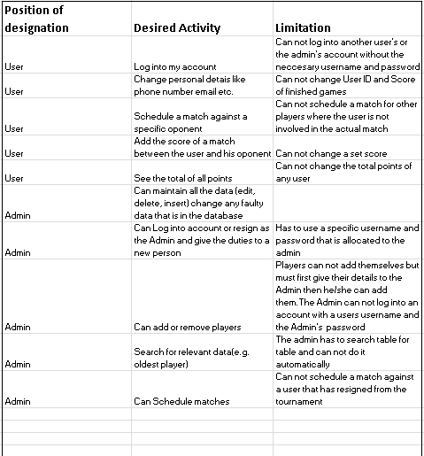

Figure 1 CaseDiagram

# Task 2: Databasis-Ontwerp

## Relationship

PlayerNo from tblPlayers has a relationship(1 to many) with PlayerA and PlayerB from tblMatches.

IDVen from tblVenue has a relationship( 1 to many) with VenueNo from tblMatches.

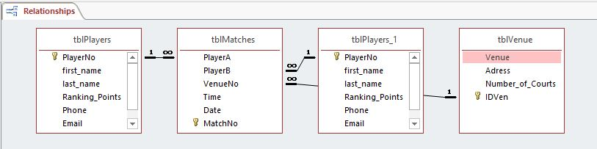

Figure 2 Relationships

## tblPlayers

All the players information is in this table with PlayerNo identifying each player.Personal information such as Phone Number, first Name Last Name etc.

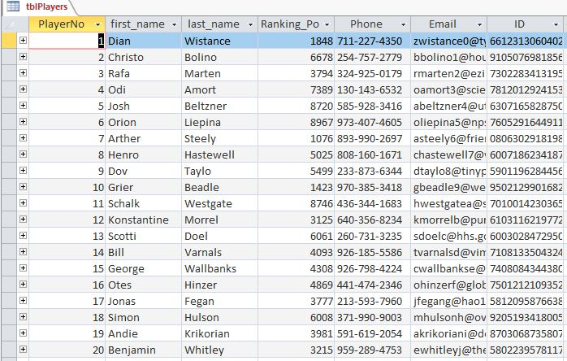

Figure 3 tblPlayers

### tblPlayers Design View

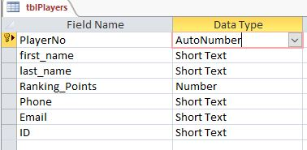

Figure 4 tblPlayers Design View

#### PlayerNo

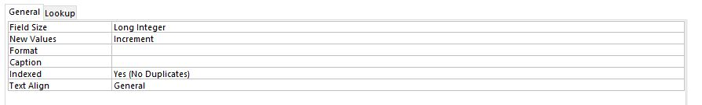

#### First Name

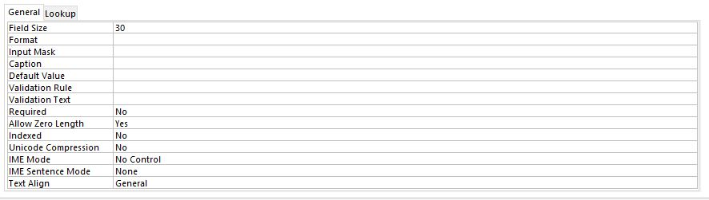

#### Last Name

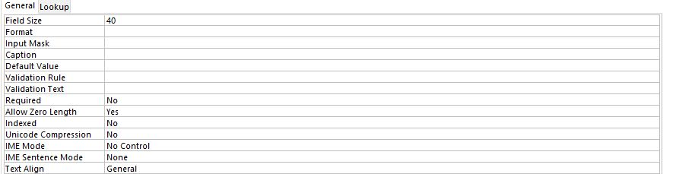

#### Ranking Points

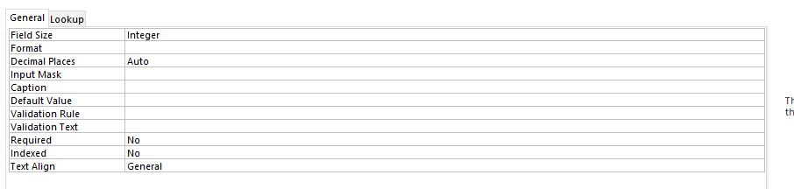

#### Phone

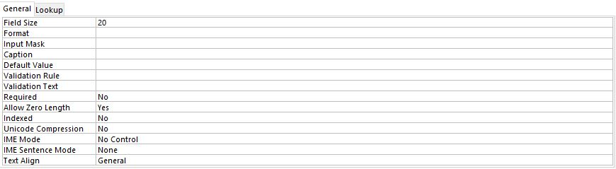

#### Email

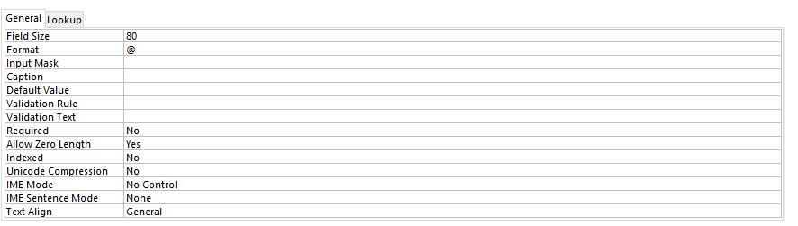

#### ID

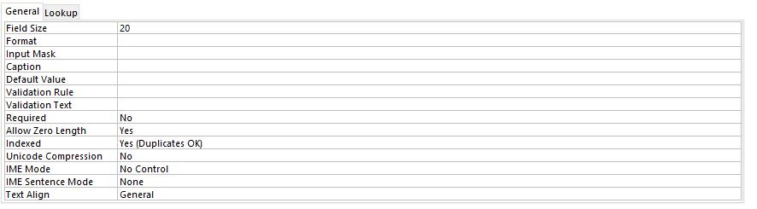

## tblMatches

All the matches is stored in this table with the scheduled time and date. When a match has been completed a check box is checked in the completed field.

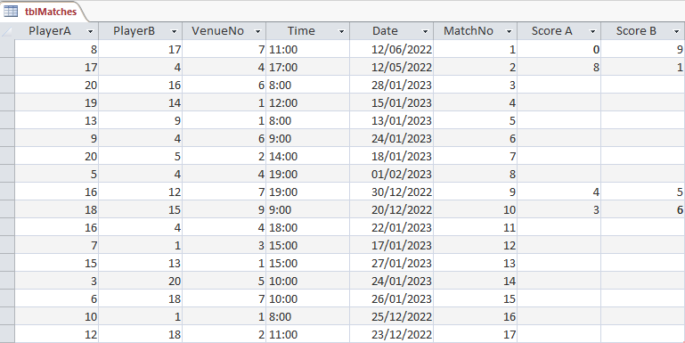

Figure 5 tblMatches

### Matches Design View

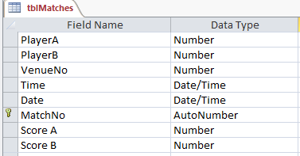

Figure 6 tblMatches Design View

#### Player A + PlayerB + VenueNo

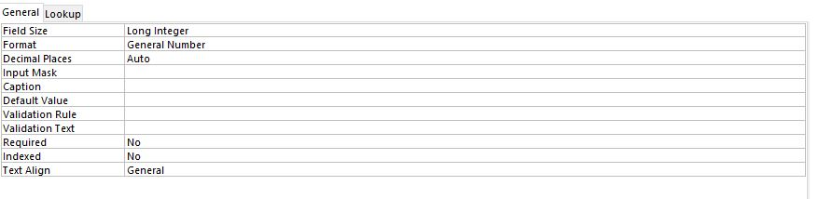

#### Time

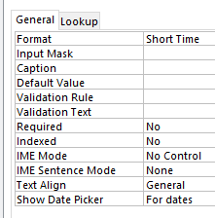

#### Date

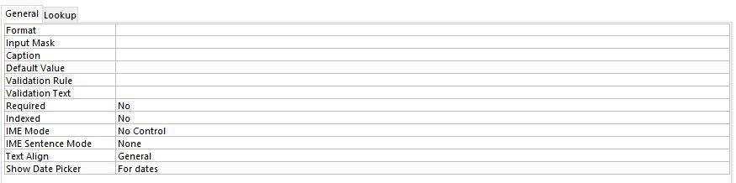

#### MatchNo

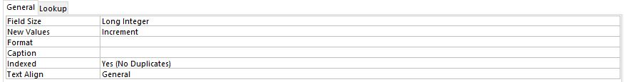

#### Score A + Score B

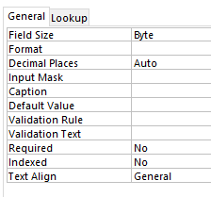

## tblVenue

All the details of the specific venue is stored in tblVenue for example the name, adress, Number of courts and the ID that is the primary key

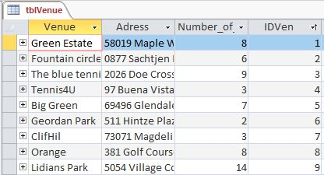

Figure 10 tblVenue

### Venue Design View

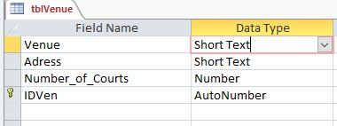

Figure 11 tblVenue Design View

#### Venue

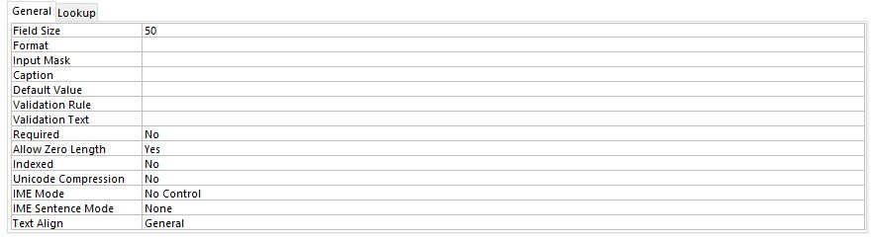

#### Adres

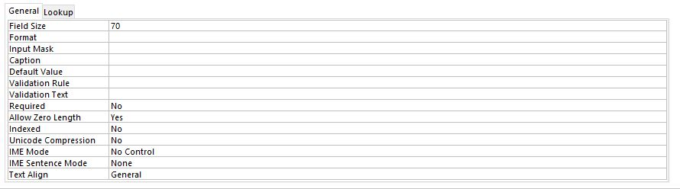

#### Number of courts

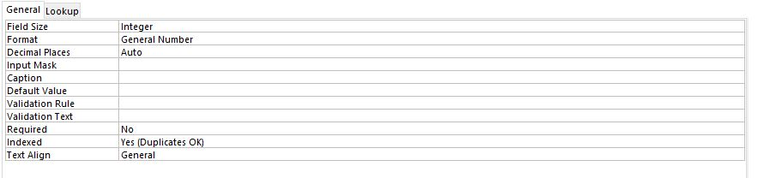

#### IDVen

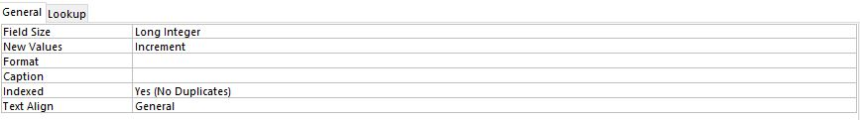

# Task 3

## A Navigation

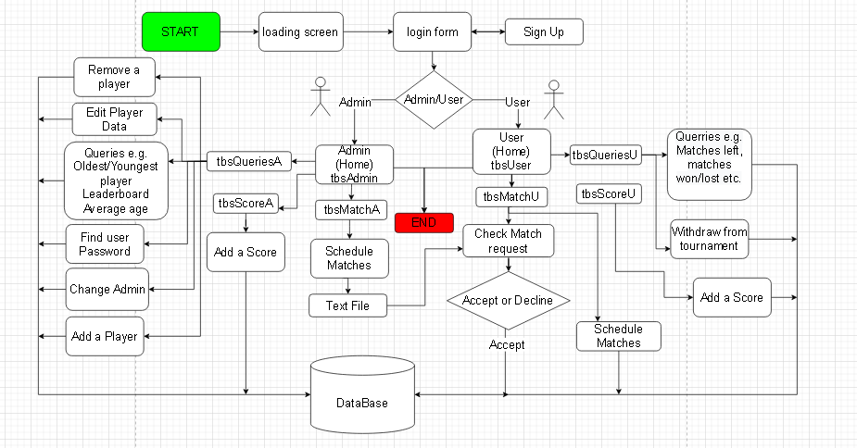

Figure 12 Navigation Flow diagram

## B GUI

### Login

#### Tbs1

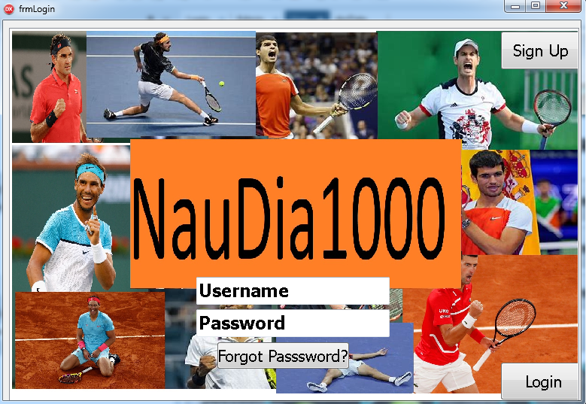

#### Tbs2

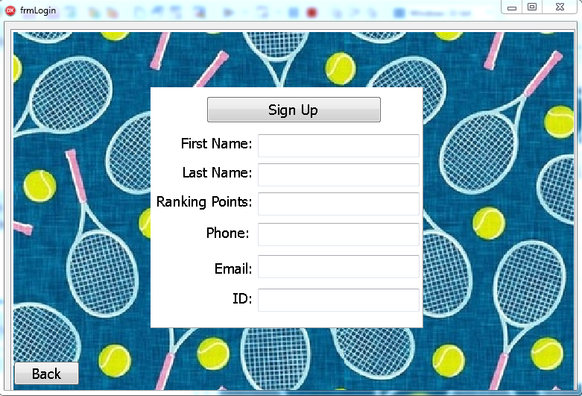

Components

TfrmLogin = class(TForm)

PageControlLogin: TPageControl;

tbsLogin: TTabSheet;

tbsAddPlayer: TTabSheet;

imgLogin: TImage;

btnLogin: TButton;

edtPass: TEdit;

edtUser: TEdit;

pnlAddPlayer: TPanel;

Label4: TLabel;

Label5: TLabel;

Label6: TLabel;

Label7: TLabel;

Label8: TLabel;

Label9: TLabel;

btnAdd: TButton;

edtName: TEdit;

EdtLastName: TEdit;

edtPoints: TEdit;

edtPhone: TEdit;

edtEmail: TEdit;

edtID: TEdit;

Image3: TImage;

btnSignUp: TButton;

btnForgot: TButton;

btnBack: TButton;

Image1: TImage;

### Admin

#### Tbs1

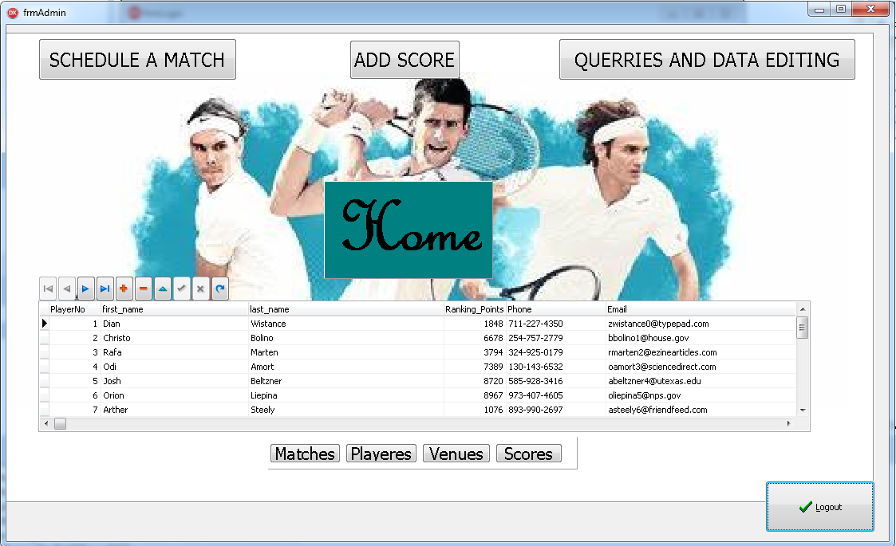

#### Tbs2

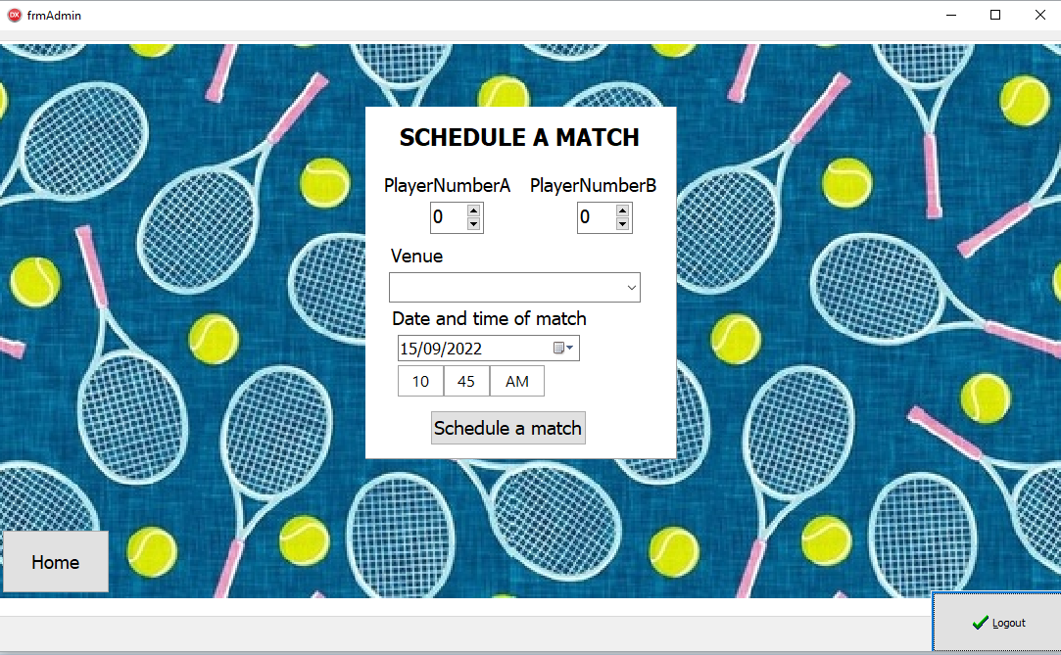

#### Tbs3

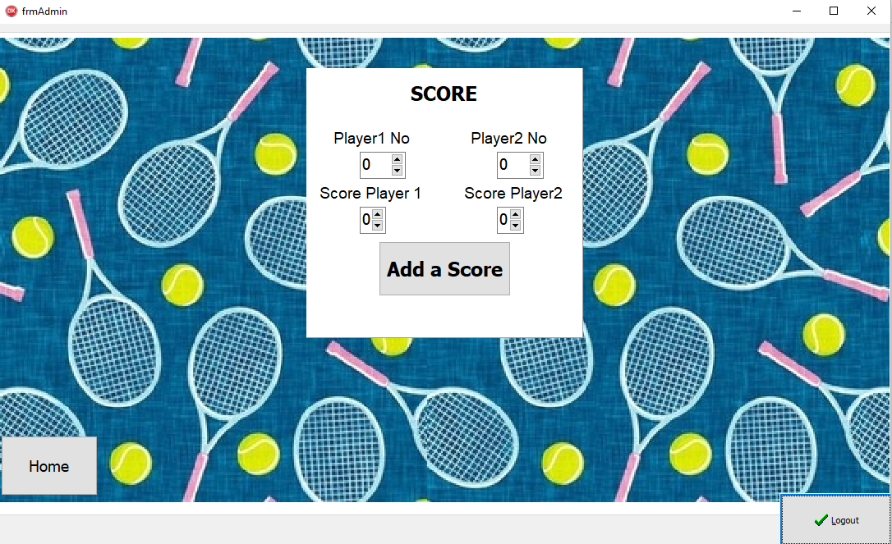

#### Tbs4

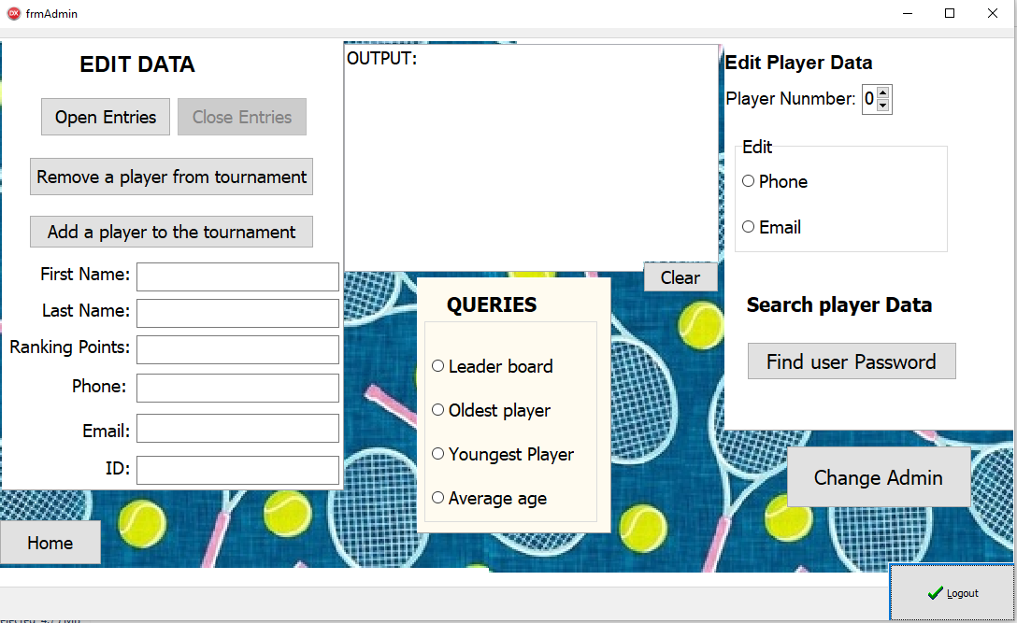

Components

TfrmAdmin = class(TForm)

lblQuerriesA: TLabel;

bmbLogoutAdmin: TBitBtn;

PageControlAdmin: TPageControl;

tbsAdmin: TTabSheet;

tbsScoreA: TTabSheet;

tbsMatchA: TTabSheet;

tbsQuerriesA: TTabSheet;

imgA1: TImage;

pnlAddScoreA: TPanel;

lblUserA: TLabel;

lblOponenetA: TLabel;

lblPlayer1: TLabel;

lblPlayer2: TLabel;

sedOponentA: TSpinEdit;

sedUserA: TSpinEdit;

btnScoringA: TButton;

sedPlayerNO1: TSpinEdit;

sedPlayerNo2: TSpinEdit;

pnlScheduleMatchA: TPanel;

lblDaterimeA: TLabel;

lblVenueA: TLabel;

lblOppNoA: TLabel;

lblPlayerB: TLabel;

dtpMatchA: TDateTimePicker;

sedPlayerAX: TSpinEdit;

tpGameA: TTimePicker;

BtnScheduleA: TButton;

sedPlayerBX: TSpinEdit;

lblSMADmin: TLabel;

DBNAdmin: TDBNavigator;

pnlTables: TPanel;

btnMatch: TButton;

Player: TButton;

btnVenue: TButton;

DBGriddDisplayAdmin: TDBGrid;

RedOutput: TRichEdit;

btnScoreTab: TButton;

btnMatchTab: TButton;

btnQuerriesTab: TButton;

imgBackround: TImage;

lblScoreInput: TLabel;

pnlQuerriesA: TPanel;

btnClear: TButton;

btnHome3: TButton;

btnHome2: TButton;

btnHome1: TButton;

Image1: TImage;

Image2: TImage;

Image6: TImage;

Image7: TImage;

Image3: TImage;

Image4: TImage;

rgpQuerries: TRadioGroup;

lblQuerries: TLabel;

Label1: TLabel;

Panel2: TPanel;

rgpEdit: TRadioGroup;

SpinEdit1: TSpinEdit;

lblEditNO: TLabel;

Label3: TLabel;

Panel1: TPanel;

lblAdmin: TLabel;

pnlAddPlayer: TPanel;

btnAdd: TButton;

edtName: TEdit;

EdtLastName: TEdit;

edtPoints: TEdit;

edtPhone: TEdit;

edtEmail: TEdit;

Label4: TLabel;

Label5: TLabel;

Label6: TLabel;

Label7: TLabel;

Label8: TLabel;

edtID: TEdit;

Label9: TLabel;

btnRemove: TButton;

Label2: TLabel;

btnCloseEntries: TButton;

btnPass: TButton;

Label10: TLabel;

btnChangeADmin: TButton;

btnOpenEntries: TButton;

cmbVenue: TComboBox;

### User

#### Tbs1

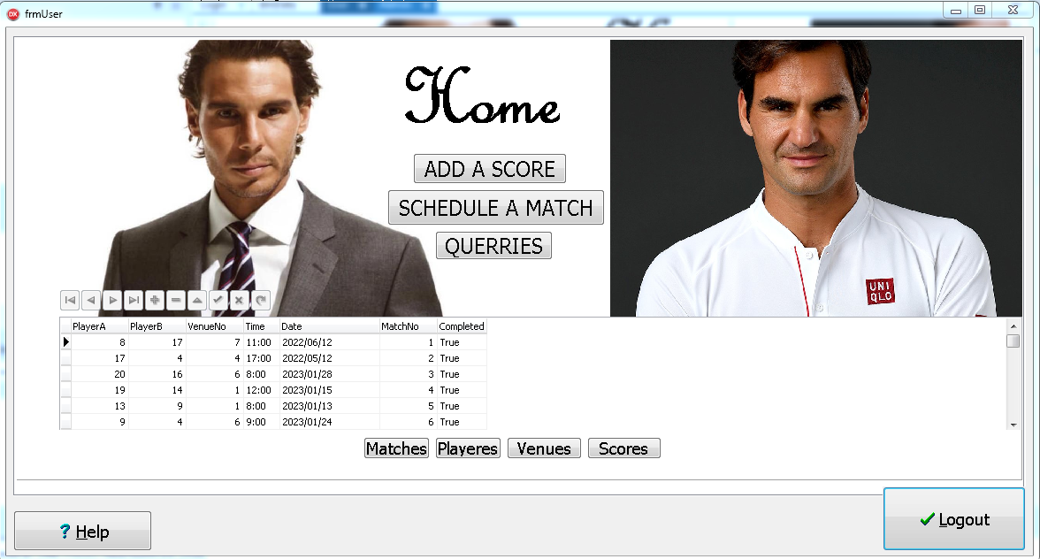

#### Tbs2

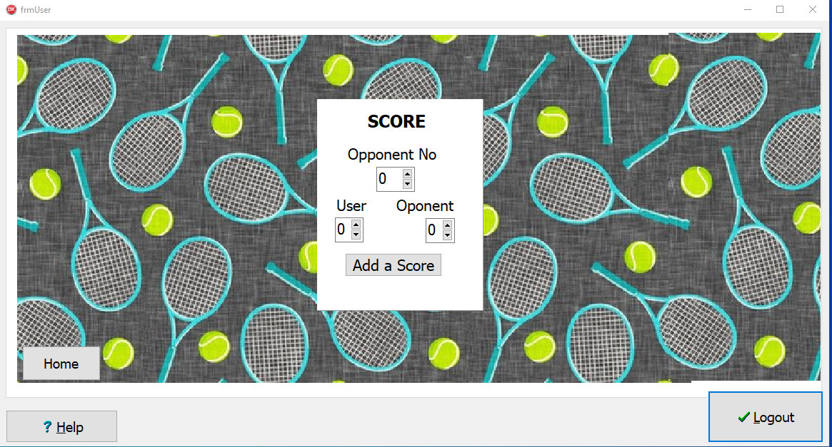

#### Tbs3

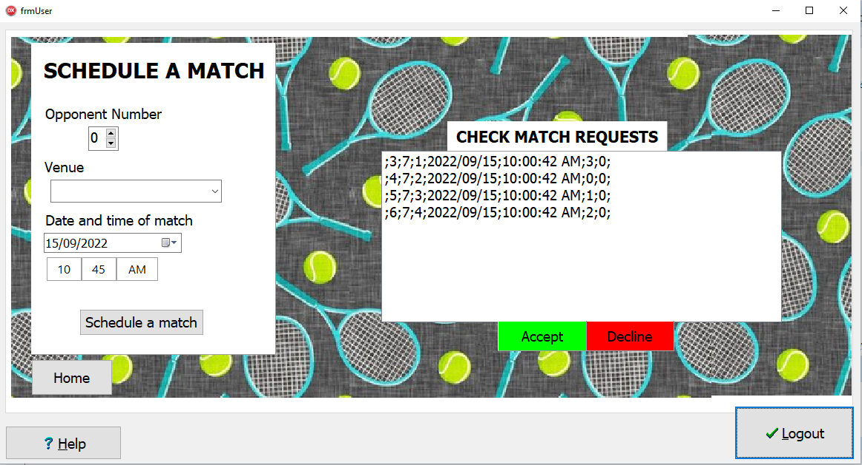

#### Tbs4

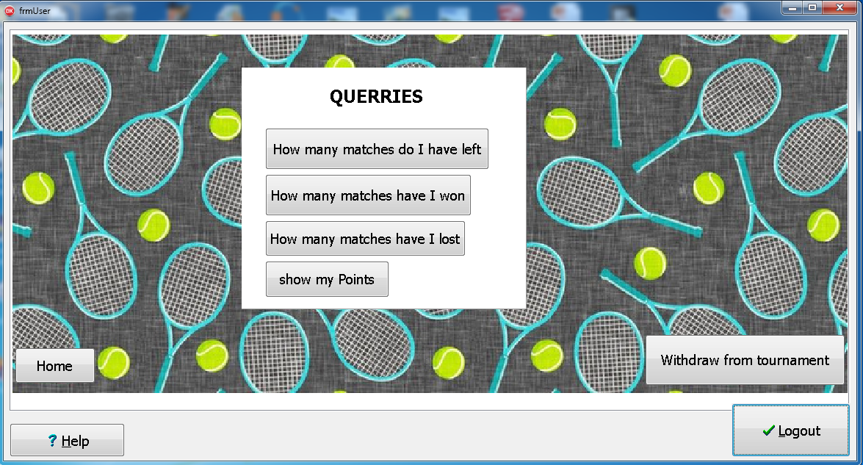

Components

TfrmUser = class(TForm)

bmbLogout: TBitBtn;

bmbHelp: TBitBtn;

PageControlUser: TPageControl;

tbsUser: TTabSheet;

tbsScoreU: TTabSheet;

tbsMatchU: TTabSheet;

tbsQuerriesU: TTabSheet;

DBGridDisplayUsers: TDBGrid;

pnlTables: TPanel;

btnMatchU: TButton;

btnPlayerU: TButton;

btnVenueU: TButton;

DBNUser: TDBNavigator;

imgP2: TImage;

imgP1: TImage;

lblHomeU: TLabel;

pnlAddScore: TPanel;

lblUser: TLabel;

lblOponenet: TLabel;

sedOponent: TSpinEdit;

sedUser: TSpinEdit;

btnScoring: TButton;

sedOPPA: TSpinEdit;

pnlScheduleMatch: TPanel;

lblDaterime: TLabel;

lblVenue: TLabel;

lblOppNo: TLabel;

dtpMatch: TDateTimePicker;

sedPlayer: TSpinEdit;

tpGame: TTimePicker;

btnMatch: TButton;

btnResign: TButton;

pnlQuerries: TPanel;

btnLeft: TButton;

btnWinrate: TButton;

btnLost: TButton;

btnMyscore: TButton;

Image1: TImage;

Image2: TImage;

Image3: TImage;

Label1: TLabel;

Image4: TImage;

Image5: TImage;

Image6: TImage;

Image7: TImage;

Image8: TImage;

Image9: TImage;

lblSM: TLabel;

lblTitlescore: TLabel;

lstRequests: TListBox;

pnlDecline: TPanel;

pnlAccept: TPanel;

pnlMatchR: TPanel;

Label2: TLabel;

Image10: TImage;

btnMatchUDirect: TButton;

btnScoreDirectU: TButton;

btnQuerriesdirectU: TButton;

btnHome1U: TButton;

btnHome3U: TButton;

btnHome2U: TButton;

cmbVenueU: TComboBox;

## IPO tables

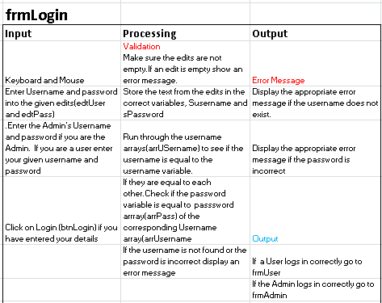

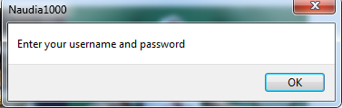

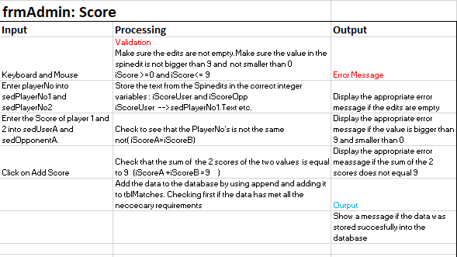

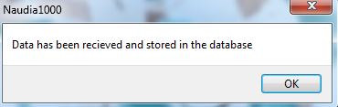

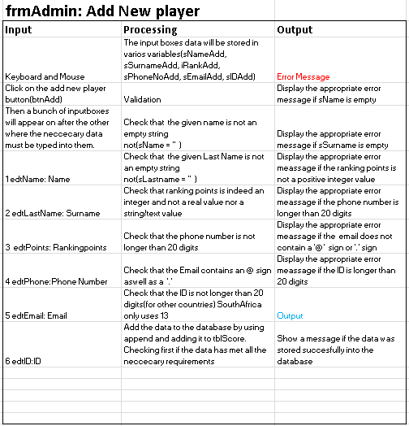

# 

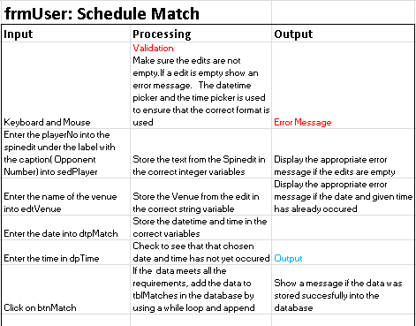

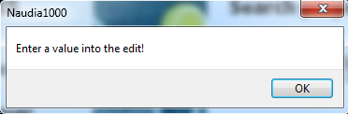

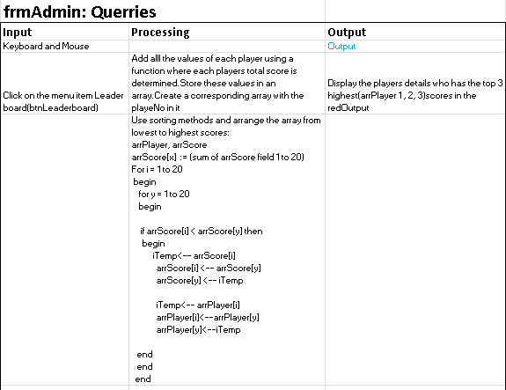

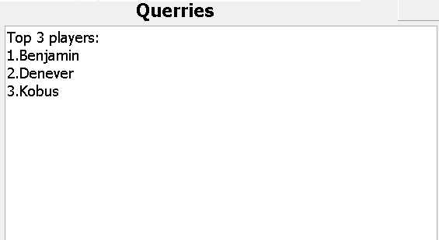

**FrmUser Querries: (1-4)**

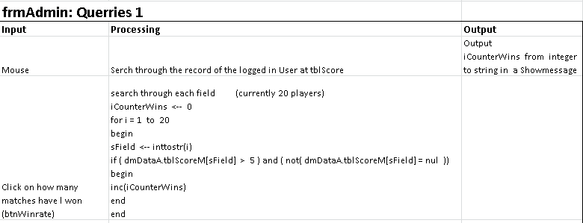

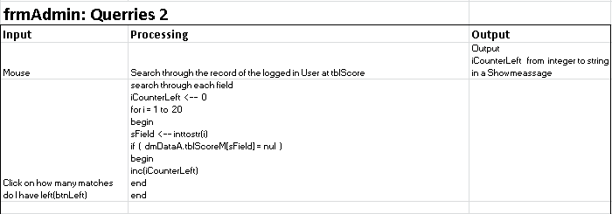

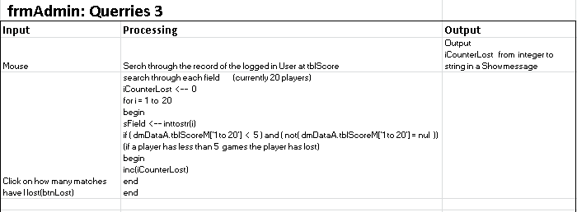

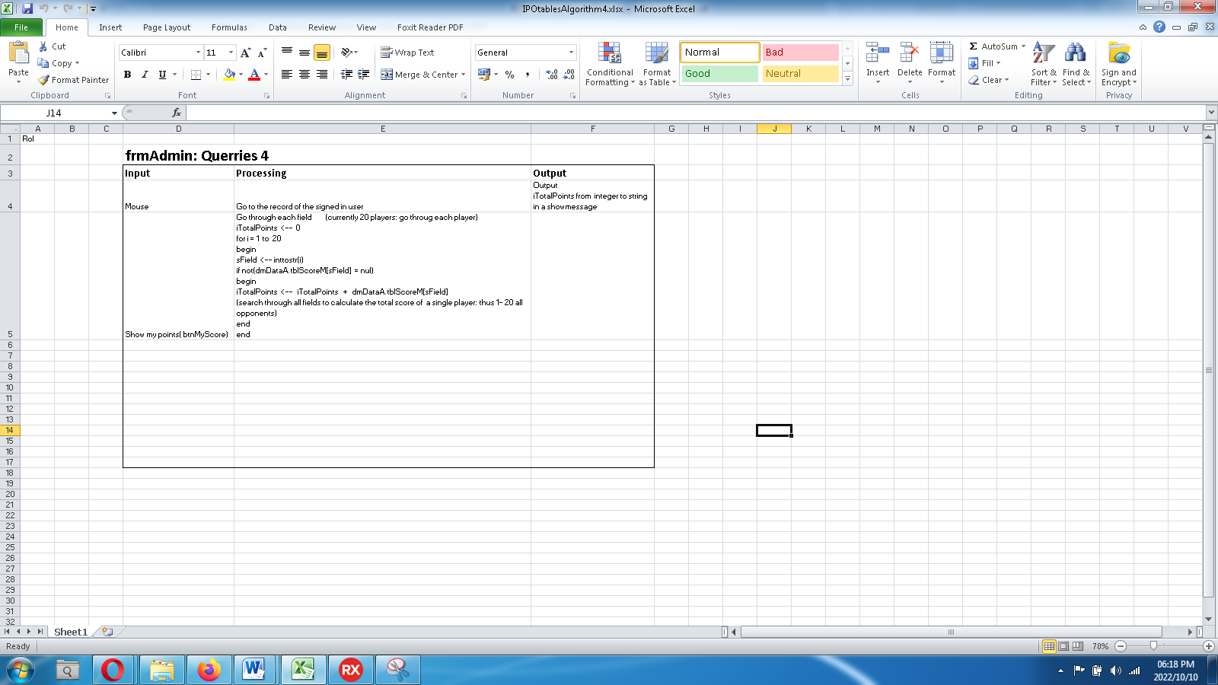

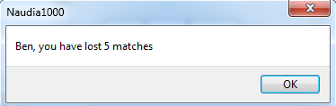

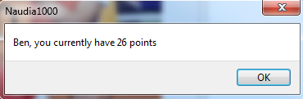

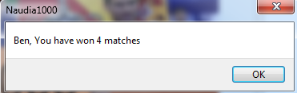

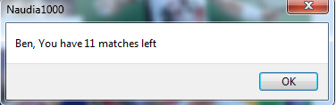

# Task 4

## Variables A

Check IPO

Variables will be used in various ways real, string, integer, Boolean etc. to calculate and finish the desired processes. Global variables will be used to identify the current logged in user from the Login form and in the User form. Thus giving a global identity of the user through the program.

## TextFile’s B

Matches will be scheduled in the program. When a match is scheduled by User A (User A is logged on) against User B the Match data is written to a text file(append) (using a delimiter “;” to separate the data). When User B is logged on. The program will read the match data from the text file(reset). The Match requests will show itself in lstRequests(listbox), the User will then be able to accept or decline the request for a match. Only then will the data be written to the database tblMatches. Text File is also used to determine whether the entries are open or closed. If the entries are open a ‘1’ is written to the text file. If the entries are closed a ‘0’ is written to the text file. Then when the program is opened it determines whether the entries are open or closed, by the Admin. Only the Admin can close Entries.

## Arrays C

Arrays will be used to store the users Password and Username. Two corresponding Arrays will be used where one contains the Username and the other contains the password. New Users can be added with their new usernames and their given password. When Logging on the program will check if the Username Corresponds with the Password if it does the User Form will be shown of that specific user. When the Admin Logs in the Admin Username will be checked to identify the Admin and check if the given password corresponds with the Admins Password. Only then will the Admin form show and the Login form hide .